Ryan Harty

Decision Analysis

11/25/19

Orion Control Case

           Nathan Armstrong, head of Marketing at Orion Controls, needs help in the assessment of a project that he is considering. Armstrong has been approached by Andre Gide, executive vice president of Avion Chemicals, who wants to purchase 50 of Orion’s Model SV44A-10 smart valve systems to manage the phenol flows at Avion’s nine chemical plants worldwide. Avion is interested in Orion’s valves due to control the highly corrosive and potentially explosive phenol flows in their plants. Gide is only now becoming interested in Avion’s technology after an explosion at a competitor’s plant. Gide is familiar with Orion’s reputation for leading edge technology and would like to strike a deal. While he would be more than fine paying for the systems as they are, he would be willing to pay top dollar if Orion is able to add a “supersmart” valve that would further reduce the phenol-handling risks that Avion faces. Now, Armstrong needs help in his decision to pursue the new technology for a potential increase in profit or to sell to Avion the valve systems as they currently are.

1.       After investigation, Armstrong should pursue the development of a new valve system. If Orion were to not pursue the development of the new valve system, they would have profit of $100,000 (Revenue = $10,000 x 50, costs = $8,000 x 50). But, the expected payoff of pursuing the development of a new valve system is $122,500. While this number is significantly higher than not pursuing the new technology, there are some risks associated with it. First off, the software development for the project would have a $40,000 monthly cost with a 75% chance of software to be finished in 3 months, and a 25% chance of the software being completed in 8 months. After the development of the software comes the uncertainty that the valve redesign will be successful. Alicia Harrington, head of Orion’s Engineering Division, estimates a 90% likelihood that the project will be successful and a 10% chance that the project will fail. No matter what the outcome of the project, the costs associated with the valve redesign will be $80,000 that will be paid to outside contract services. If the valve redesign is successful, there is an 80% chance that the improvements will be warrant a 100% increase in premium for the new valves, and a 20% chance that the valve that the valves will only warrant a 20% increase in premium. Another factor to consider is that if the new valves get produced, they will incur an extra $2,500 per unit cost, bringing the total variable cost to $10,500. The other aspect that needed to be accounted for was the decision to either produce the old technology or build the new technology-dependent on past outcomes. By creating a decision tree where every cost and probability was accounted for, the expected profit from pursuing the new technology is $122,500, which is why Orion should pursue the new valve technology.

2.       When the development of the project was a success, but the changes to the valve were modest, the option to design the old valve decreased losses by $2,500 for both the quick finish and slow finish chances. But a more important option would take place in the case of software development taking longer than three months. If the development takes longer than that time frame, then Armstrong should build the original valve system. The value of this option would be worth -$20,000, if he were to continue the pursuit of the operation it could cost him as much as -$365,000 with the highest projected payoff of $35,000.

3.       In the case where software development is quick, if the project always gets finished it is worth $275,000 as opposed to $200,000 which would lead to an increase in that option of $75,000. Likewise, for the possibility of long software development, the value of the option always getting completed is worth $35,000 as opposed to -$40,000 which would lead to an increase for that option of $75,000. In addition, the value of the project would now be worth $177,500, which is an increase in the overall value of $55,000.

4.       If Armstrong could make a deal that would determine how fast the software development could be designed, then they would only develop the software when it was quick which would bring the value of the project to $170,000 opposed to $122,500 that it was with the uncertainty of the speed of development. The value of this information would be worth $47,500.

Graph 1

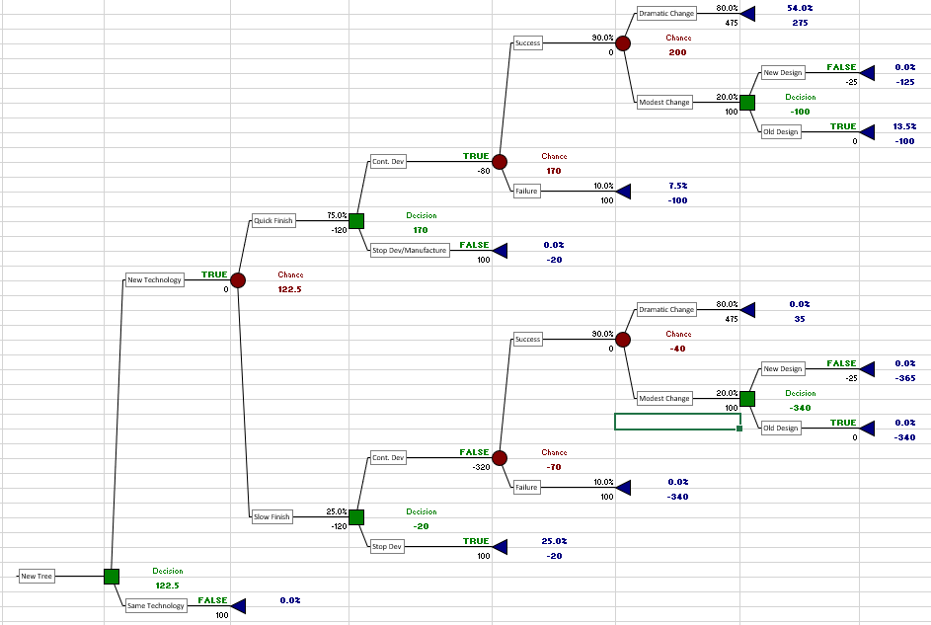

Graph 2 (Value of project success)

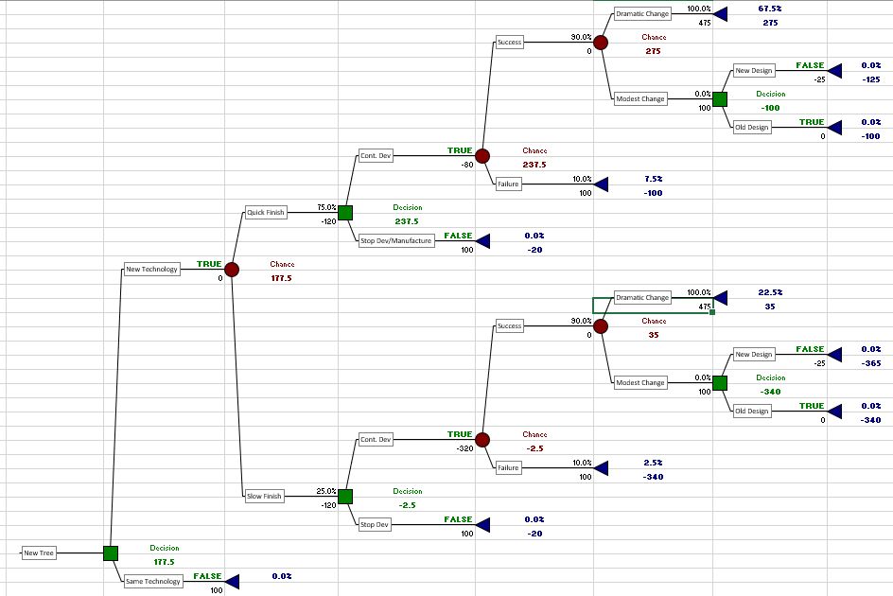

Graph 3 (value of knowing how long software would take to be developed)

